import tkinter as tk

from tkinter import ttk

from tkinter import colorchooser, messagebox

from tkinter.filedialog import asksaveasfile

import qrcode

import cv2 as cv

import pyzbar.pyzbar as pyzbar

import numpy as np

app_title = "QR Code Generator and Scanner in Python"

win = tk.Tk()

win.title(app_title)

width = 480

height = 180

screenwidth = win.winfo_screenwidth()

screenheight = win.winfo_screenheight()

alignstr = '%dx%d+%d+%d' % (width, height, (screenwidth - width) / 2, (screenheight - height) / 2)

win.geometry(alignstr)

win.resizable(width=False, height=False)

qr_default_fg_color = "black"

qr_default_bg_color = "white"

def save_and_display():

files = [('PNG Image', '*.png')]

file_path = asksaveasfile(filetypes=files, defaultextension=files).name

if file_path:

generate_qr(file_path)

img = cv.imread(file_path)

cv.imshow('QR Code', img)

cv.waitKey(0)

cv.destroyAllWindows()

def choose_fg_color():

global qr_default_fg_color

color_code = colorchooser.askcolor(title="Choose QR Foreground Color")

qr_default_fg_color = color_code[1]

def choose_bg_color():

global qr_default_bg_color

color_code = colorchooser.askcolor(title="Choose QR Background Color")

qr_default_bg_color = color_code[1]

def generate_qr(file_path):

input_URL = LineEditURL.get()

if input_URL != '':

qr = qrcode.QRCode(

version=1,

error_correction=qrcode.constants.ERROR_CORRECT_L,

box_size=15,

border=4,

)

qr.add_data(input_URL)

qr.make(fit=True)

img = qr.make_image(fill_color=qr_default_fg_color, back_color=qr_default_bg_color)

img.save(file_path)

messagebox.showinfo(app_title, "QR Code generated successfully")

else:

messagebox.showerror(app_title, "Please enter URL / Link / Web Address to generate QR Code")

def read_qr_from_webcam():

cap = cv.VideoCapture(0)

while True:

ret, frame = cap.read()

decoded_objects = pyzbar.decode(frame)

for obj in decoded_objects:

print("Data:", obj.data.decode('utf-8'))

messagebox.showinfo("QR Code Data", obj.data.decode('utf-8'))

cv.imshow('QR Code Scanner', frame)

if cv.waitKey(1) & 0xFF == ord('q'):

break

cap.release()

cv.destroyAllWindows()

LineEditURL = ttk.Entry(win)

LineEditURL.place(x=30, y=30, width=345, height=25)

BtnGenerate = ttk.Button(win, text="Generate", command=save_and_display)

BtnGenerate.place(x=380, y=29, width=70, height=27)

BtnBackgroundColor = ttk.Button(win, text="Choose QR Background Color", command=choose_bg_color)

BtnBackgroundColor.place(x=29, y=60, width=210, height=30)

BtnForegroundColor = ttk.Button(win, text="Choose QR Foreground Color", command=choose_fg_color)

BtnForegroundColor.place(x=240, y=60, width=210, height=30)

BtnScanQR = ttk.Button(win, text="Scan QR Code from Webcam", command=read_qr_from_webcam)

BtnScanQR.place(x=29, y=90, width=420, height=30)

win.mainloop()

* Khi chạy đoạn code, chúng ta thu được giao diện đầu tiên như sau :

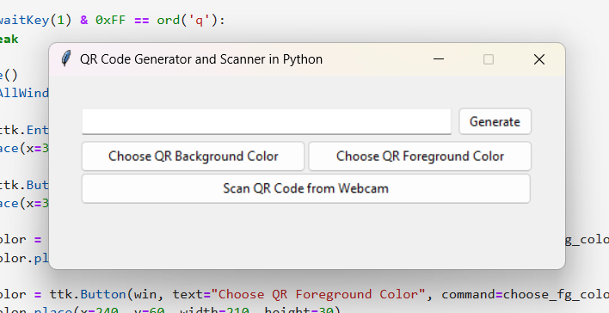

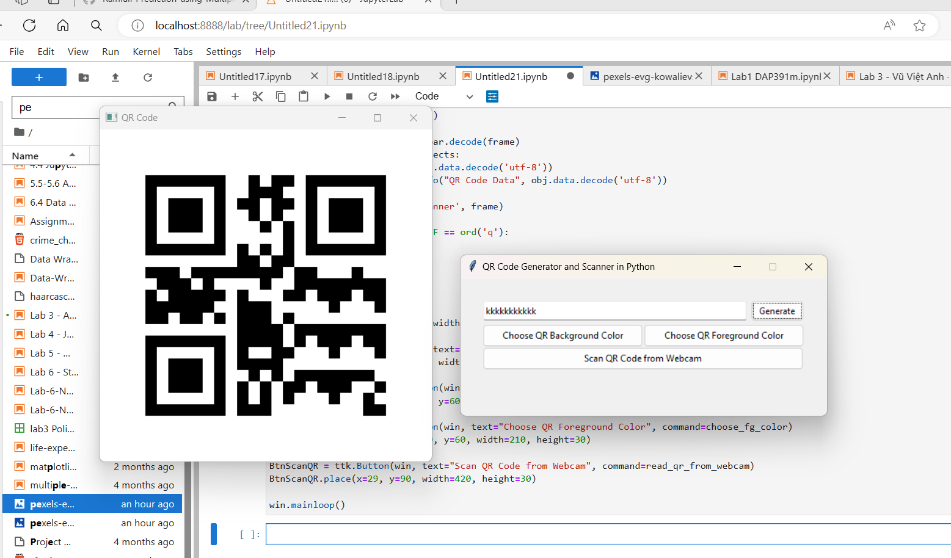

Nhập nội dung văn bản và lưu ảnh QR cho thuận tiện sau này sử dụng.

* Ngoài ra ta có thể sử dụng chức năng Scan QR code để lấy nội dung văn bản. Sau khi quét QR code sẽ hiện ra 1 box để hiển thị nội dung văn bản.

